基隆市五堵國民小學一○九學年度第一學期期中評量試卷三年級語文領域(英語科)試卷
班級： 座號： 姓名： 得分： 家長簽章：

一、Listening Test 聽力測驗：36％
Part A: Listen and Check 聽錄音，勾選相對應的字母及單字圖片：8％
- m 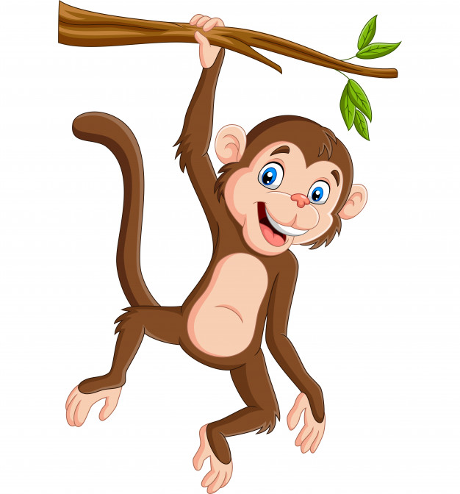 l 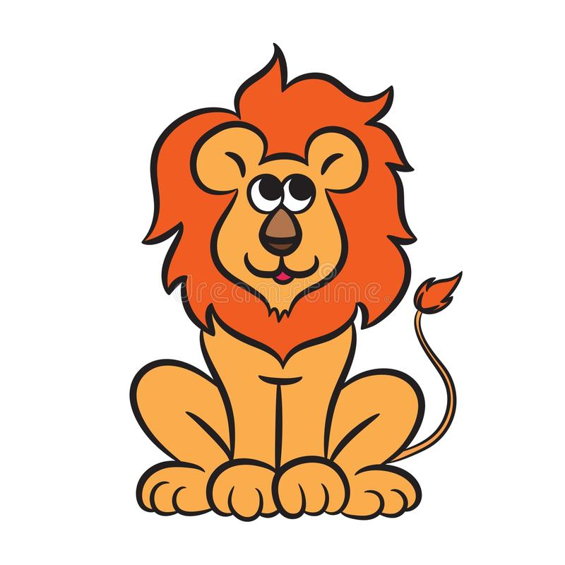
- o g
- k 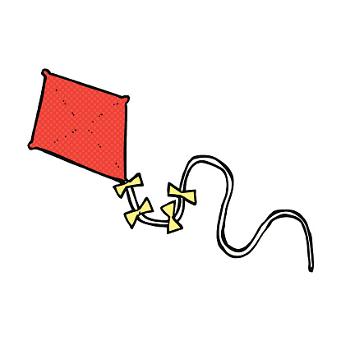 h
- d 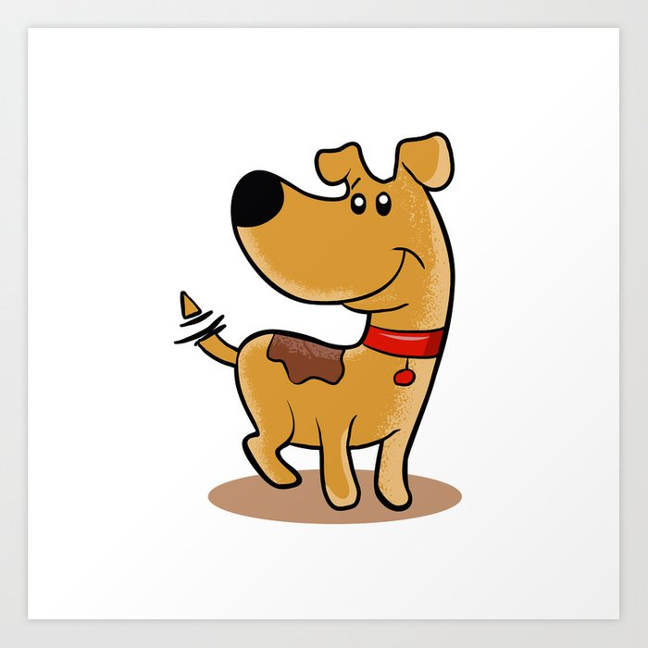 b 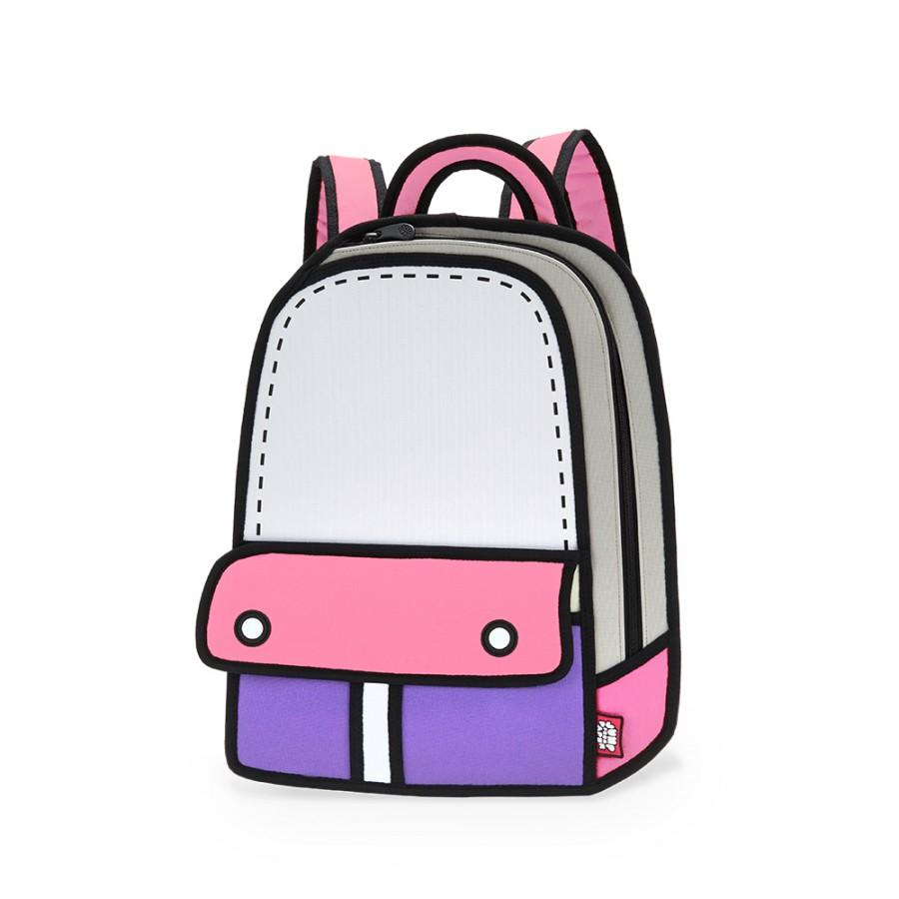
Part B: Listen and Check 聽錄音，勾選與句意相符的圖片：4％
- ( ) ( ) 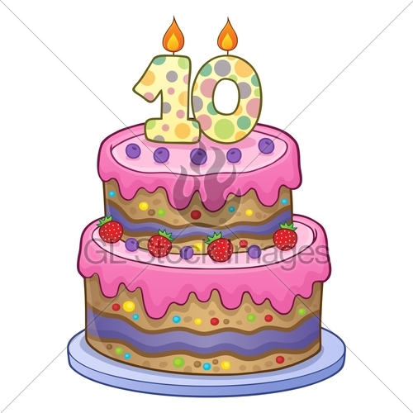 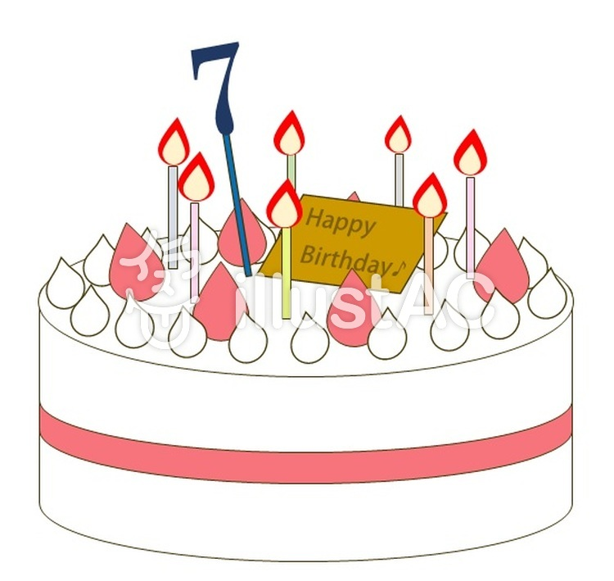
- ( ) ( )
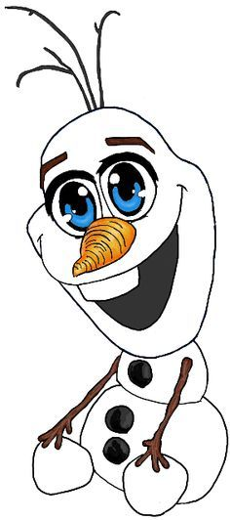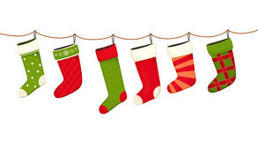
Part C: Listen and Number 聽錄音，將圖片依序標號：8％
( )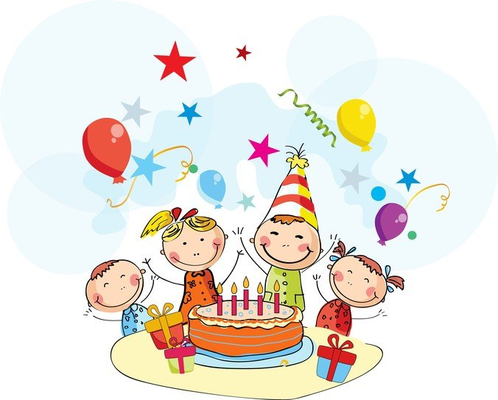( )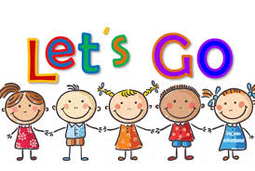
( ) ( )
Part D: Listen and Number 聽錄音，將字母標號：16％
- ( ) Ee ( ) Hh
- ( ) Jj ( ) Ff
- ( ) Nn ( ) Mm
- ( ) b ( ) d
- Circle 圈出正確的答案：8％
- ( i / I ) am six years old.
- Look! ( Santa / santa ) is here.
- ( Thank / thank ) you.
- ( happy / Happy ) birthday!
- Write將數字由大到小寫下來：8％
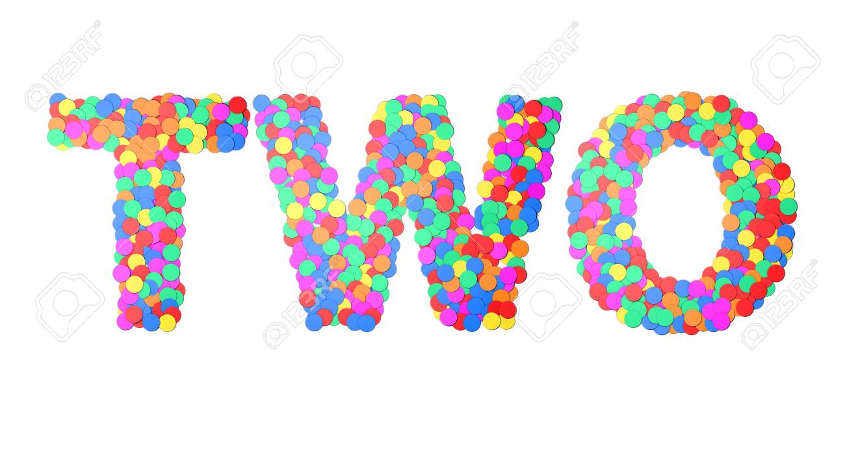
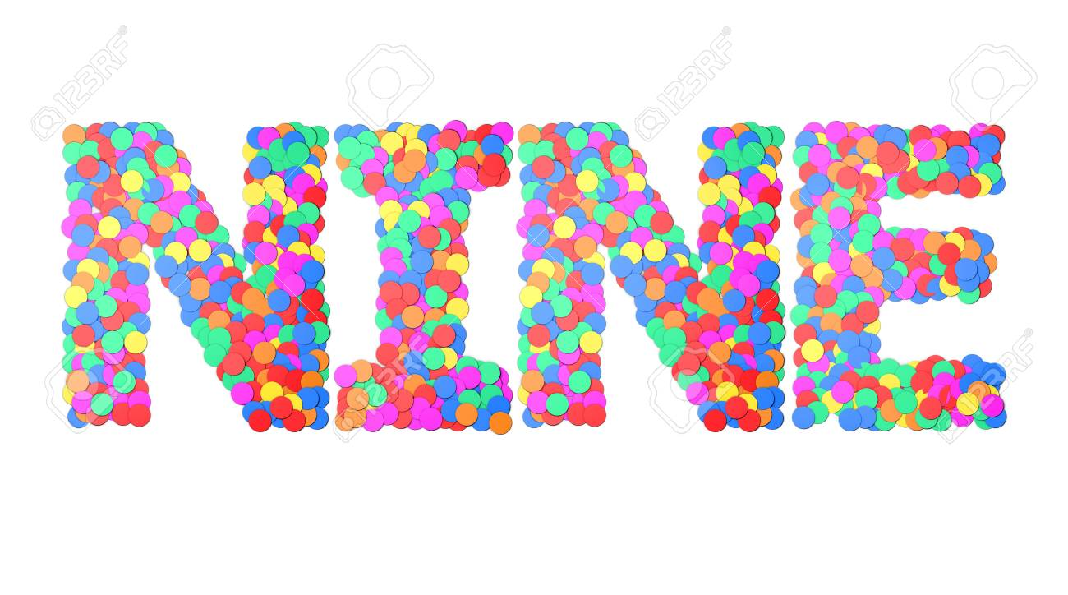
( 10 ) ( ) ( ) ( ) ( )
- Classify選出不同的選項：12％
( ) 1. (A) ox (B) bear (C) bell
( ) 2. (A) dog (B) ant (C) cat
( ) 3. (A) fish (B) snake (C) goat
( ) 4. (A) big (B) bag (C) star
( ) 5. (A) Santa (B) stockings (C) tiger
( ) 6. (A) bread (B) egg (C) ear
- Write大小寫互換：8％
- JAM 3. INK
- hat 4. lion
六﹑Spelling拼出正確的單字：8％
- 什麼 hatw
- 網子ent
- 抱歉 oyrsr
- 猴子 ymnoke
七﹑Unscramble 重組句子：8％
- your ∕ ? ∕ What’s ∕ name

- How old ∕ ? ∕ you / are
八、Match 連一連：4％
- 仙子麵包 ・ ・ fairy bread
- 握手 ・ ・ shake hands
- 拉耳朵 ・ ・ take a bow
- 鞠躬 ・ ・ ear pulling
九﹑Reading 閱讀測驗：8％
Today is Christmas, and it’s also Toby’s birthday. He’s seven. A big Christmas tree is in the house. Toby and Fifi come into the house. Everyone says “Happy birthday!” and gives Toby a gift. Toby is happy and says thank you to them.
( ) 1. How old is Toby?
(A) 7 (B) 6 (C) 9
( ) 2. Is Toby happy today?
(A) Yes, you are.
(B) Yes, he is.
(C) No, he isn’t.
( ) 3. We say “____” on Christmas.
(A) Happy birthday!
(B) Good job!
(C) Merry Christmas!
( ) 4. Today is ______ birthday.
(A) Kevin’s (B) Fifi’s (C) Toby’s

