基隆市五堵國民小學一一○學年度第一學期期末評量試卷三年級語文領域(英語科)試卷
班級： 座號： 姓名： 得分： 家長簽章：
- Listening Test: 38%
Part A: Listen and Circle 聽錄音，圈選正確的單字字首音字母
  - Gg Tt 4. Rr Zz
  - Mm Nn 5. Bb Pp
  - Ll Rr 6. Kk Gg
Part B: Listen and Circle 聽錄音，圈選正確的答案
1. 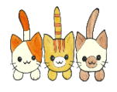
2. 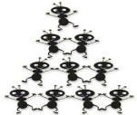 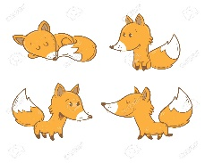
3.
4. 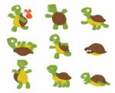 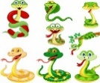
Part C: Listen and Circle 聽錄音，圈選正確的答案
1.
2. 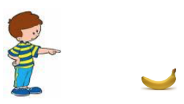
3. 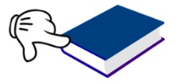
4.
Part D: Listen and Choose 聽錄音，選出適當的回應句
( ) 1.(A) It’s blue.
- It’s a blue pen.
(C) It’s a white eraser.
( ) 2.(A) I’m ten.
(B) It’s sunny.
(C) I’m fine, thanks!
( ) 3.(A) I’m ten.
(B) It’s sunny.
(C) I’m fine, thanks!
( ) 4.(A) I’m ten.
(B) It’s sunny.
(C) I’m fine, thanks!
( ) 5.(A) Good morning.
(B) Good afternoon.
(C) Good night.
- Classify 選出不同的選項: 10%
( ) 1. (A) yellow (B) vest (C) indigo
( ) 2. (A) zoo (B) window(C) school
( ) 3. (A) eraser (B) key (C) ruler
( ) 4. (A) cup (B) van (C) car
( ) 5. (A) tiger (B) lion (C) elephant
- Read and Write 讀一讀，依序寫出正確的字母：6％
1.

2.
- Read and Write 讀一讀，將大寫改成小寫，小寫改成大寫：12％
- VISA 3. sony
- pepsi 4. BMW
- Unscramble 重組句子：10％
- see ∕ ! ∕ I / rainbow ∕ a
- Teddy ∕ morning / . / , / Good

- Spelling 拼出正確的單字:10%
- 兔子 rtbiba
- 烏龜 ttreul
- 小測驗 uziq
- 粉紅色的 ikpn
5. 脖子 cnke
- Reading 閱讀後，填入正確的答案代號：12％
- books (B) library
(C) Lost and Found (D) bag
Teddy and Mia are at the ________ today. Teddy likes to read ________ there. Oh, no! Teddy lost his ________. He left it on the sofa. He is very sad now! Luckily, Teddy found his bag at the ________ counter.
left 遺留(leave過去式) sofa 沙發
Luckily 幸運地 found找到(find過去式) counter 櫃台
八、Write down an idea to avoid forgetting to bring things home next time! 2%
(寫下如何避免自己下次又忘了帶東西回家的好辦法!) * 中英文回答皆可
___________________________________
___________________________________

