基隆市五堵國民小學一一○學年度第一學期期中評量試卷三年級語文領域(英語科)試卷
班級： 座號： 姓名： 得分： 家長簽章：

一、Listening Test 聽力測驗：32％
Part A: Listen and Circle 聽錄音，圈選聽到的首字母：8％
- 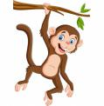 ( m / n )onkey
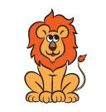 ( I / l )ion
- ( a / o )x
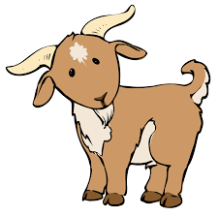 ( j / g )oat
- 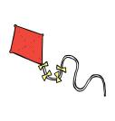 ( k / g )ite
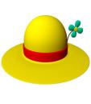 ( f / h )at
- 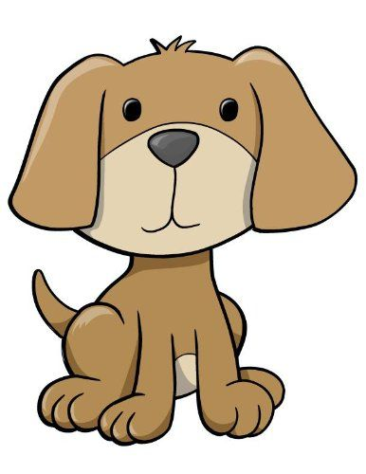 ( b / d )og
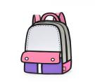 ( b / d )ag
Part B: Listen and Choose 聽錄音，選出適當的回應句：8％
( ) 1.(A) I’m ten.
(B) He’s nine years old.
(C) I’m fine.
( ) 2.(A) You’re welcome.
(B) Good job.
(C) I’m fine.
( ) 3.(A) Thank you.
(B) You’re welcome.
(C) I’m fine.
( ) 4.(A) I am teddy.
(B) She is Abu.
(C) I’m Mia.
Part C: Listen and Number 聽錄音，將圖片依序標號：8％
( ) 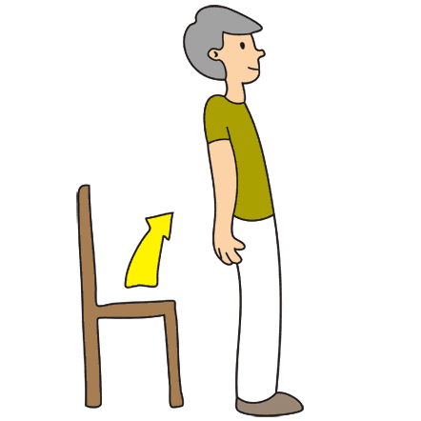 ( ) 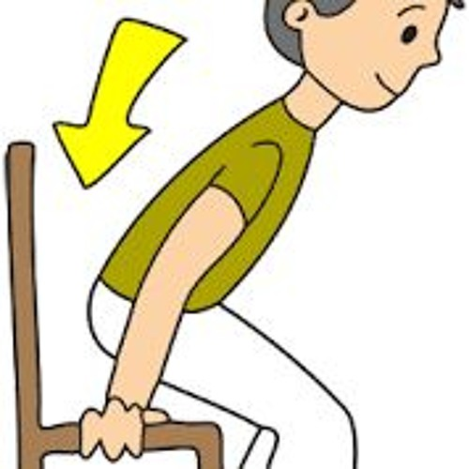
( ) ( ) 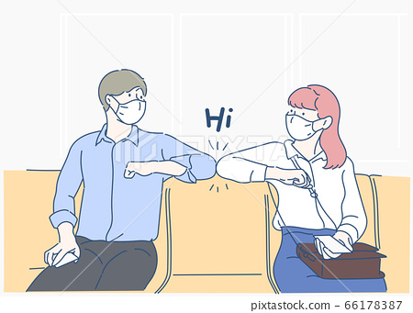
Part D: Listen and Circle 聽錄音，圈選聽到的字母：8％
- b d
- j i
- E F
4. M N
- Circle 圈出正確的答案：10％
- ( i / I ) am ( Amber / amber ).
- ( My / my ) name is Rocky.
- ( Thank / thank ) you.
- ( what’s / What’s ) your name?
- Write將數字由大到小寫下來：8％
5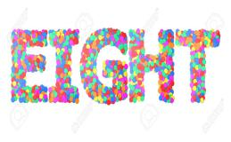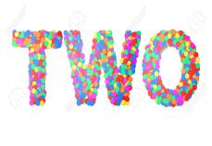
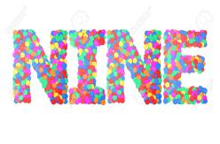
( 10 ) ( ) ( ) ( ) ( )

- Classify選出不同的選項：18％
( ) 1. (A) ox (B) goat (C) bag
( ) 2. (A) ant (B) insect (C) otter
( ) 3. (A) bat (B) nose (C) leg
( ) 4. (A) elephant (B) lion (C) fish
( ) 5. (A) ink (B) juice (C) milk
( ) 6. (A) cat (B) dog (C) cup
- Write大小寫互換：12％
- HAND

- spider

- witch

- NECK
六﹑Spelling拼出正確的單字：8％
- 什麼 tahw

- 七 enesv

- 四 orfu

- 噴射機 tje

七﹑Reading 閱讀測驗：12％
(Knock! Knock! Knock!)
Treat or trick! Happy Halloween!
Look! Edison is a vampire. Mia is a spider. Amber is a witch. Teddy and Rocky are ghosts. They want a pumpkin to make a Jack-o'-lantern. Everyone is happy on Halloween.
( ) 1. How many boys are there?
(A) 2 (B) 3 (C) 4
( ) 2. How many ghosts are there?
(A) 2 (B) 3 (C) 4
( ) 3. We say “____” to ask for candy on Halloween.
(A) Happy birthday!
(B) Trick or treat!
(C) Merry Christmas!
( ) 4. What is a Jack-o'-lantern like?
- 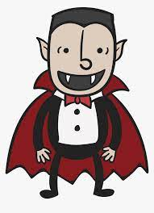
- 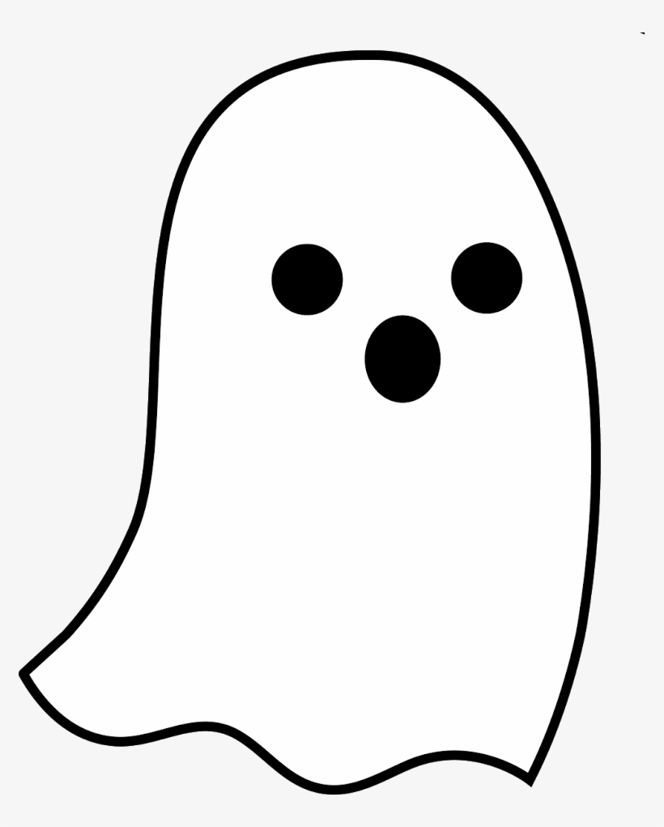
(C) 