**基隆市五堵國民小學一○八學年度第學一期期中評量試卷六年級語文領域(英語科)試卷**

**班級： 座號： 姓名： 得分： 家長簽章：**

1. **Listening Test 聽力測驗：**

**（30%，每題2分）**

**Part A: Listen and Circle 聽錄音，圈出正確的發音例字**

1. back　 bake 4. bait　 beat
2. bit　 bite 5. clean　 gleam
3. Pete pet 6. plane plan

**Part B: Listen and Circle “T” or “F”**

**聽錄音，與對話內容相符的圈”T”，不符的圈”F”**

1. Susan goes to school at six thirty.

( T / F )

1. Susan gets up early on weekends.

( T / F )

1. Susan wants some Fench fries for dinner tonight.

( T / F )

**Part C: Listen and Check 聽錄音，勾選正確的圖片**

**( )** 習作P5-4 **( )** 習作P6-3

**( )** 習作P6-7 **( )** 習作P6-5

**( )** 習作P29-3 **( )** 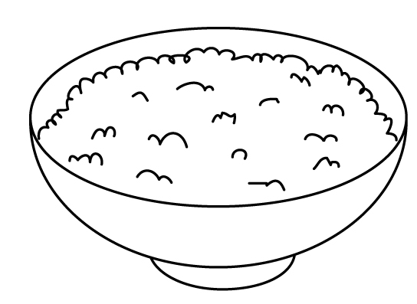

**二、Read and Circle 圈出畫線部分發音不同的字：（10%，每題2分）**

1. ( mask make bay )
2. ( rain plate five )
3. ( peach pie Pete )
4. ( try lake play )
5. ( feet train meat )

**三、Choose 文法選擇：（16%，每題2分）**

1. A: What time does Joan ________ dinner?  
   B: She ________ dinner at seven thirty.  
   (A) have, have(B) have, has(C) has, has
2. Victor doesn’t ________ early. He ________ at nine thirty.  
   (A) gets up, gets up(B) gets up, get up(C) get up, gets up
3. I’m ________ now. I could eat a horse!  
   (A) glad(B) angry(C) starving
4. A: ________ you an early bird?  
   B: Yes, I ________.  
   (A) Are, am (B) Do, do

(C) Can, can

1. A: Who teaches you English?  
   B: ______ does.   
   (A) My parents (B) My brothers

(C) My dad

1. The beef _______ very yummy. Would you like some?  
   (A) don’t look(B) looks(C) look
2. A: What ________ you want to eat?  
   B: I want some dumplings.  
   (A) would (B) does (C) do
3. A: Would you like some ________?  
   B: No, thank you.  
   (A) chicken(B) noodle

(C) hot dog

**四、Unscramble 重組句子：**

**（22%，每字1分）**

1. bird ∕ Be ∕ an ∕ Kevin. ∕ early ∕ ,

＿＿＿＿＿＿＿＿＿＿＿＿＿＿＿___

1. food ∕share ∕can ∕ our ∕ with∕ We ∕everyone.

＿＿＿＿＿＿＿＿＿＿＿＿＿＿＿___

1. Pass ∕ brush ∕ me∕ the ∕ please. ∕ ,   
     
   ＿＿＿＿＿＿＿＿＿＿＿＿＿＿＿___

**五、Look and Write 看圖寫出正確的問句或回應句：（12%，每題4分）**

1. 課本P22-1

A: ＿＿＿＿＿＿＿＿＿＿＿＿＿____

B: Yes, please.

1. 習作P25-1  
   A: What time does Andy have breakfast?

B: ＿＿＿＿＿＿＿＿＿＿＿＿＿____

1. 課本P34-5

A: ＿＿＿＿＿＿＿＿＿＿＿＿＿____  
B: We’d like some noodles.

**六、Reading Comprehension 閱讀測驗：（10%，每題2分）**

Pete and Eve like the sea. They are thirty. They are having afternoon tea by the sea. Coffee for Eve and tea for Pete. Pete wants to bake an apple pie. The pie is for Eve because she’s the apple of his eye. A bee is flying around their feet, so they decide to go home early. They would like some steak, French fries and corn soup for dinner. After dinner, they go to the movies together. They both have a lot of fun tonight.  
🕮 together 一起 both 兩者都

corn 玉米 decide 決定  
( ) 1. Where do Pete and Eve go after dinner?  
(A) The beach.   
(B) A movie theater.   
(C) A supermarket.  
( ) 2. Does Pete like Eve?  
(A) Yes, he does.  
(B) No, he doesn’t.   
(C) I don’t know.   
( ) 3. What do Pete and Eve have for dinner?  
(A) Noodles. (B) Beef. (C) Fried chicken.  
( ) 4. How old is Eve?  
(A) 30. (B) 15. (C) 13.

( ) 5. What would Pete like to drink for the afternoon tea?  
(A) Tea. (B) Coffee. (C) Soda.

* ***Check twice! Good luck !!!***

***檢查兩遍。祝你好運！！！***