基隆市五堵國民小學一○八學年度第一學期期中評量試卷四年級語文領域(英語科)試卷
班級： 座號： 姓名： 得分： 家長簽章：

一、Listening Test 聽力測驗：30％（每題2分）
Part A: Listen and Check 聽錄音，勾選與字首發音對應的字母
- □ p □ b 4. □ d □ t
- □ g □ c 5. □ b □ p
- □ t □ d 6. □ c □ g
Part B: Listen and Choose 聽錄音，選出正確的句子代號
( ) 1. ( ) 2. ( ) 3.
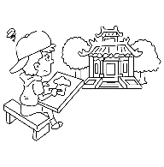 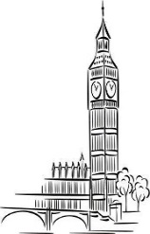
( )4. ( )5. 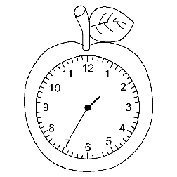 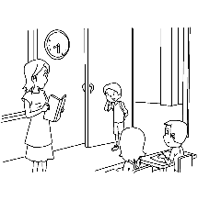
Part C: Listen and Number 聽錄音，將圖片依序標號
( ) 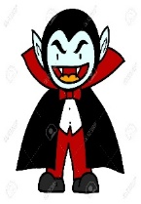( )
( ) 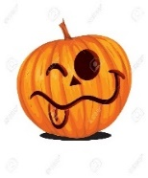( )
二﹑Read and Write 寫出英文數字：
6％（每題2分）
三、Choose 文法選擇：16％（每題2分）
( ) 1. A: What’s this? B: It’s ＿＿＿.
(A) a bike (B) green (C) ten o’clock
( ) 2. Ted ＿＿＿ read. I can help him.
(A) is (B) isn’t (C) can’t
( ) 3. A: Can she dance?
B: ＿＿＿, she can.
(A) Not (B) No (C) Yes
( ) 4. A: Can David dance?
B: No, ＿＿＿.
(A) he can (B) he can’t (C) I can’t
( ) 5. A: Can ＿＿＿ sing? B: Yes, I can.
(A) he (B) she (C) you
( ) 6. A: What ＿＿＿ ?
B: It’s twelve twenty.
(A) time is this(B) time is it(C) color is it
( ) 7. A: Look! I have a new＿＿＿. It can tell the correct time. correct 正確的
B: How cool!
(A) witch (B) water (C) watch
( ) 8. It’s nine o’clock.
Time ＿＿＿ bed.
(A) for (B) at (C) in
四﹑Look, Read and Write 看圖寫出正確的對應句：6％（每題3分）
- A: Can you sing?
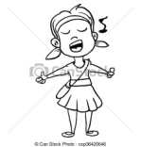
B:
- 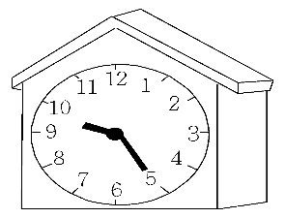
A:
B: It’s nine twenty-five.
五﹑Unscramble 重組句子：
16％（每字1分）
1. read ∕ ? ∕ book ∕ Toby ∕ a ∕ Can
- twenty-five ∕ . ∕ seven ∕ It’s
- late ∕ I / am ∕ . ∕ Sorry / ,

六、Look, Read and Mark 圖文相符畫“O”，不符畫“X”：16％（每題2分）
( ) 1.
Toby: Oh, no! I can’t swim.
Tina: Are you OK?
( ) 2. 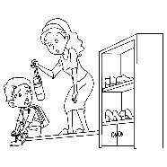A: What’s that?
B: It’s a ruler.
( ) 3. 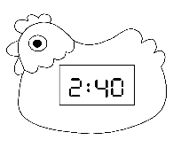It’s two forty.
( ) 4. 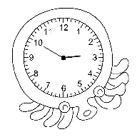It’s three fifteen.
( ) 5. 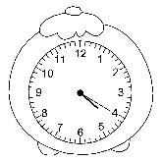 It’s four forty.
( ) 6. 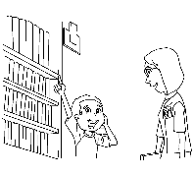A: Try again. B: OK.
( ) 7. Tom: Can you dance?
Sue: Yes, I can.
( ) 8. A: Time for dinner!
B: Yummy!
七﹑Reading Comprehension 閱讀測驗：
10％（每題2分）
Toby: Tina, let’s go trick-or-treating!
Tina: I can’t wait, Toby. I’m playing a cat woman.
Sandy: I’m playing a witch. Who’s playing a vampire?
Toby: Kevin is. And Jack is playing a ghost. Look! Fifi is scared.
Tina: What are you playing, Toby?
Toby: I’m playing a zombie.
Tina: How cool!
Sandy: Look! There are jack-o’-lanterns. Everyone is having fun tonight. Let’s go play!
( ) 1. Is Fifi happy tonight?
(A) Yes, she is.(B) Yes, she can.
(C) No, she isn’t.
( ) 2. What holiday is today?
(A) It’s Christmas.
(B) It’s Halloween.
(C) It’s New Year’s Day.
( ) 3. What do we say to people on 10/31?
(A) Happy New Year!
(B) Merry Christmas!
(C) Happy Halloween! people 人們
( ) 4. Who is scared?
(A) Toby (B) Kevin (C) Fifi
( ) 5. Who is playing a zombie?
(A) Toby (B) Kevin (C) Tina

- Check twice! Good luck !!!
- 檢查兩遍。祝你好運！！！

